Documentation

*Document*

**Title**: Astro_project

**Fecha**: 30/10/2024

**Nombre del Autor**: Dmytro Reva

Index

Explanation - 3

Explanation - 3

Explanation - 7

Explanation - 9

Explanation - 14

Explanation - 19

Explanation - 20

Explanation - 23

Explanation - 23

Explanation - 27

Explanation - 27

Explanation - 28

Explanation - 28

Explanation - 31

Version 1.0

Provide a technical overview of the class, its purpose, and its features.

### Explanation -

Code Summary for Documentation:

The provided code represents a component built using Astro, a modern static site generator, which displays a card containing an image and a theme title. The component retrieves three properties from the `Astro.props`: `img`, `tema`, and `url`, which correspond to the image source, the theme title, and the link URL, respectively.

The main structure is wrapped in an anchor (`

Version 1.0

Provide a technical overview of the class, its purpose, and its features.

### Explanation -

Code Summary for Documentation:

This code defines a contact page using Astro, a modern static site generator. It imports essential components such as `Header`, `Footer`, and `Layout`, which structure the overall design of the page. The data required for display, specifically user contact details, is fetched asynchronously from a database using the `getDatos` function.

Upon loading the component, the `getDatos` function is invoked to retrieve and store data in a variable called `data`. This data includes the user's full name, email, and phone number, which are displayed within a structured layout. The page consists of a main content area that includes a header, a section for contact information, availability hours, and social media links.

The `Layout` component is used to encapsulate the main content, while the `Header` and `Footer` components provide consistent navigation and footer functionality across all pages. The contact section is styled to create an inviting user interface, utilizing CSS to set background colors, margins, paddings, and text alignments. Hover effects are applied to social media icons for improved user interaction.

Furthermore, the availability section clearly outlines the hours during which the user can be contacted, enhancing the utility of the page. The styling ensures a cohesive look and feel, with a focus on readability and user experience. Links are formatted to enhance accessibility, allowing users to easily send emails or make phone calls directly from the page.

Overall, this code provides a well-structured and visually appealing contact page, effectively utilizing components and styles to create a user-friendly interface.

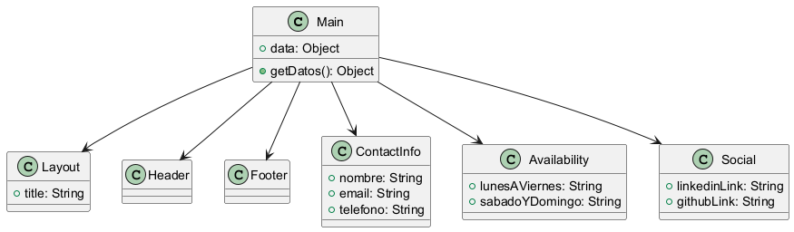

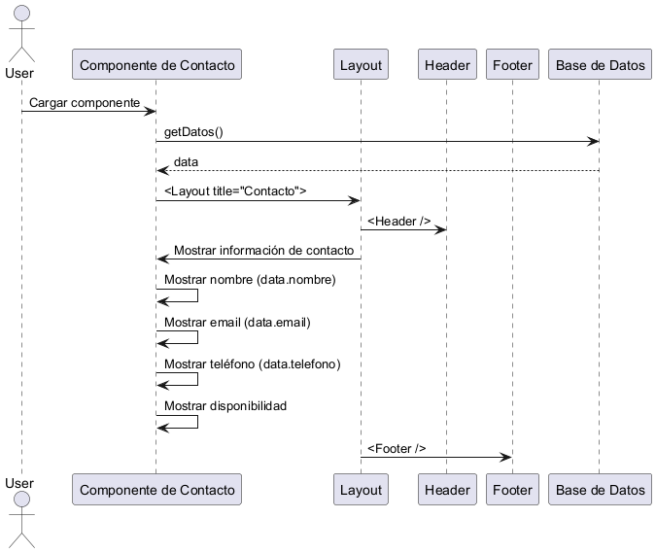

# Time Complexity Analysis

The provided code snippet is primarily focused on rendering a contact page using the Astro framework. The main computational activity occurs during the data fetching and rendering processes. Here’s a breakdown of the time complexity analysis:

1. Data Fetching:

- The line `let data = await getDatos();` indicates an asynchronous call to fetch data from the database.

- The time complexity of this operation depends on the implementation of the `getDatos` function. If it involves a database query, the complexity can vary based on the database indexing and the nature of the query. Typically, database queries can be considered as O(1) for simple lookups or O(n) for more complex queries where `n` is the number of entries being scanned.

- Since the function is awaited, it will block the rendering until the data is fully retrieved.

2. Rendering Components:

- The components `Header`, `Footer`, and `Layout` are rendered in constant time, O(1), as there are no loops or recursive calls involved in rendering these components.

- The HTML structure is static and does not depend on the size of the input data. Therefore, the rendering of the HTML markup that displays the contact information is also O(1).

3. Static Content:

- The sections that display static content, such as the availability and social media links, also have a constant time complexity of O(1) since they do not depend on any variable input.

4. Final Complexity:

- The overall time complexity for the initial rendering of this page can be summarized as O(d), where `d` is the time complexity associated with the data fetching operation, which is the most time-consuming part of the process. This could be O(1) in the best case (simple query) or up to O(n) in the worst case (full table scan).

### Conclusion

In conclusion, the time complexity of the code snippet is primarily dictated by the data fetching operation. The rendering of the components and static content is efficient with a time complexity of O(1). Therefore, the overall time complexity can be approximated as O(d), with `d` reflecting the complexity of the data fetching process.

Code Review Summary

### Identified Issues:

1. Await at Top Level: The use of `await` at the top level of the script may not work as expected in all environments. It would be better to wrap it in an async function.

2. Target Attribute Typo: The `target` attribute for the social media links is set to `_blanc`, which should be `_blank`.

### Recommendations for Improvement:

1. Async Handling: Enclose the data fetching logic in an asynchronous function to avoid potential issues with top-level await.

```javascript

async function fetchData() {

data = await getDatos();

}

fetchData();

```

2. Error Handling: Implement error handling for the `getDatos` function to manage cases where data might not be retrieved successfully.

```javascript

try {

data = await getDatos();

} catch (error) {

console.error("Error fetching data:", error);

}

```

3. Accessibility: Consider adding `aria-label` attributes to the social media links for improved accessibility.

### Areas of Strength:

- Component Structure: The use of components (Header, Footer, Layout) promotes reusability and better organization.

- Styling: The CSS provides a clean and modern layout. The use of transitions in SVGs enhances user experience.

### Potential Bugs:

- If `getDatos` returns null or undefined, accessing `data.nombre`, `data.email`, or `data.telefono` will throw an error. Ensure that data is validated before usage.

### Performance Bottlenecks:

- The inline SVGs for social icons could be replaced with a single icon library to reduce the load time and improve maintainability.

### Security Vulnerabilities:

- Ensure that the data fetched from `getDatos` is sanitized before rendering to prevent XSS (Cross-Site Scripting) attacks, especially for user-generated content.

### Overall Code Quality Assessment:

Score: 7/10

- The code is well-structured and maintains a clear separation of concerns. However, improvements in error handling, asynchronous execution, and accessibility could enhance its robustness and usability.

Version 1.0

Provide a technical overview of the class, its purpose, and its features.

### Explanation -

Code Summary for Documentation:

The provided code is a component written in Astro, which is a modern framework for building fast websites. It is structured to present a Curriculum Vitae (CV) with an option to toggle between Spanish and English versions.

### Key Components:

1. Imports:

- The code imports the `Footer`, `Header`, and `Layout` components, which are essential for structuring the page.

- It also imports a function `getDatos` from a database module to fetch user data asynchronously.

2. Data Fetching:

- The data is fetched using `await getDatos()`, allowing the page to load user-specific information, such as the user's name, which is used to dynamically set the title of the layout.

3. Layout Structure:

- The main content is wrapped in a `

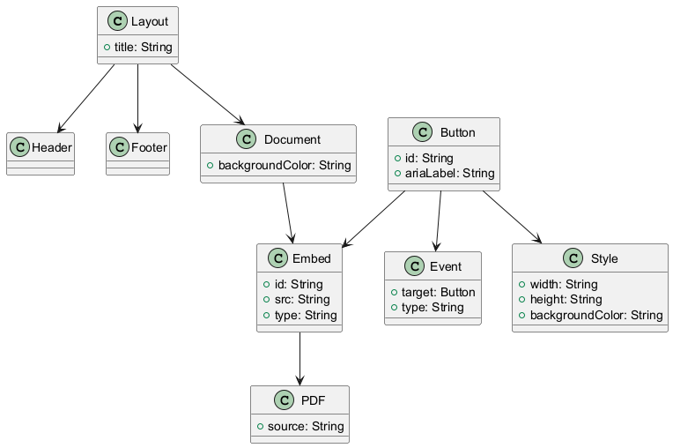

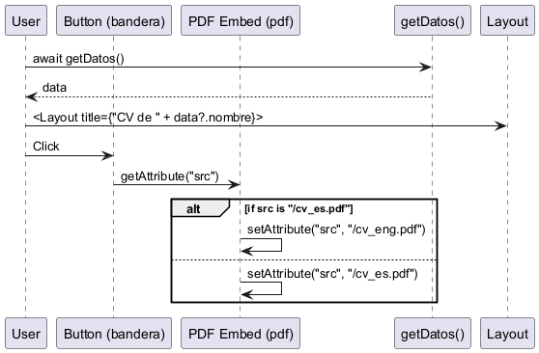

Time Complexity Analysis

The provided code snippet is a component built using Astro, which primarily focuses on rendering a layout with a header, footer, and content area that includes a button for toggling between two PDF documents.

1. Data Fetching:

- The line `let data = await getDatos();` involves an asynchronous call to fetch data. The time complexity for this operation depends on the implementation of the `getDatos` function, which is not provided. If we assume it fetches data from a database or API, the complexity could range from O(1) for a cached response to O(n) for fetching n records from a database.

2. Rendering Components:

- The rendering of the `Header`, `Footer`, and main content is O(1) as it does not depend on the size of the input but rather on the fixed number of components being rendered.

3. Event Listener:

- The event listener attached to the button is an O(1) operation since it merely toggles the source of the PDF embed element based on a condition. The operations inside the listener (checking the current source and setting a new source) are constant time operations.

4. CSS Styles:

- The styles defined in the `

Version 1.0

Provide a technical overview of the class, its purpose, and its features.

### Explanation -

Code Summary for Documentation:

This code is an implementation of a Node.js module that facilitates asynchronous interactions with a MySQL database using the `mysql2/promise` library. It defines a connection pool for efficient database management and includes three primary asynchronous functions to retrieve data from the database.

1. Connection Pool Creation: The module establishes a connection pool to the MySQL database with specified configurations such as host, port, user credentials, and database name. The pool allows for a maximum of 10 simultaneous connections, ensuring efficient resource usage and management.

2. Data Retrieval Functions:

- `getDatos`: This function retrieves general data from the 'datos' table. It acquires a connection from the pool, executes a SELECT query to fetch all rows, and maps the results into a JavaScript object using a `Map`. Each row's 'dato' serves as the key, and 'valor' serves as the value. The function handles exceptions and ensures the connection is released back to the pool after the operation.

- `getProjects`: This function fetches project details along with their associated technologies from the 'projects' table. It executes a complex query that joins multiple tables (`projects`, `projects_tecnologias`, and `tecnologias`). The results are organized in a `Map` where each project ID is associated with its details and a list of related technologies. The function also ensures error handling and proper connection management.

- `getHabilidades`: This function retrieves skills from the 'habilidades' table. It maps the resulting rows into an array of skill objects, each containing properties like ID, image, name, description, and URL. Similar to the other functions, it includes error handling and connection cleanup.

Overall, this module provides a structured approach to interact with the database, ensuring efficient connection management and data retrieval while handling potential errors gracefully.

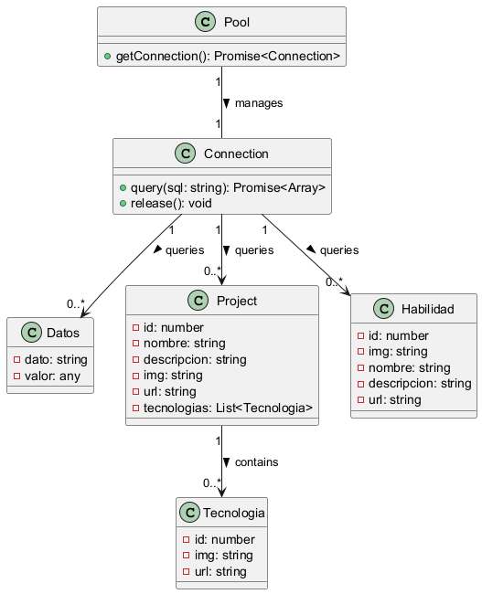

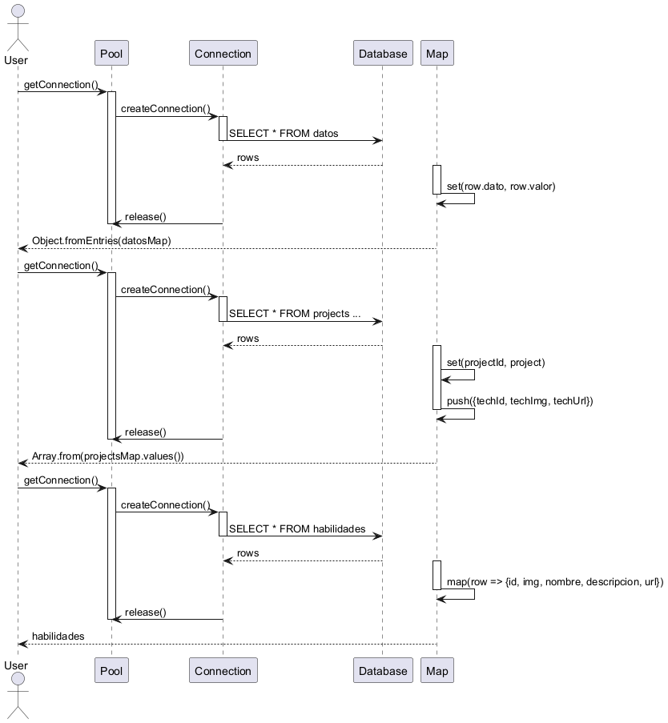

# Time Complexity Analysis

The provided code consists of three asynchronous functions that interact with a MySQL database using the `mysql2/promise` library. Each function retrieves data from the database and processes it. Below is the time complexity analysis for each function:

## 1. `getDatos()`

### Database Query

- The function executes a query: `SELECT FROM datos`.

- The complexity of this query depends on the number of rows `n` in the `datos` table. Generally, fetching all rows is O(n).

### Data Processing

- After retrieving the rows, the function iterates over them to create a `Map`. This operation is O(n) since it processes each row once.

### Total Time Complexity

- The overall time complexity for this function is O(n) due to the query and the subsequent iteration over the results.

---

## 2. `getProjects()`

### Database Query

- The function executes a complex query involving `LEFT JOIN`s:

```sql

SELECT ... FROM projects p

LEFT JOIN projects_tecnologias pt ON p.id = pt.project_id

LEFT JOIN tecnologias t ON pt.tecnologia_id = t.id

```

- The complexity of this query is influenced by the number of projects `p`, the number of technologies `t`, and the relationships between them. In the worst-case scenario, assuming the relationships are not optimized, this could be O(n m), where `n` is the number of projects and `m` is the number of technologies.

### Data Processing

- The function iterates over the resulting rows to populate a `Map`. The processing of these rows is also O(k), where `k` is the total number of rows returned by the query.

### Total Time Complexity

- The overall time complexity for this function is O(n m + k), where `k` is generally less than or equal to `n m`, leading to a simplified complexity of O(n m).

---

## 3. `getHabilidades()`

### Database Query

- The function executes a query: `SELECT FROM habilidades`.

- Similar to `getDatos()`, the complexity of this query is O(m), where `m` is the number of rows in the `habilidades` table.

### Data Processing

- The function maps each row to a new format using `rows.map`. This operation is also O(m).

### Total Time Complexity

- The overall time complexity for this function is O(m).

---

### Summary

- getDatos(): O(n), where `n` is the number of rows in the `datos` table.

- getProjects(): O(n m), where `n` is the number of projects and `m` is the number of technologies.

- getHabilidades(): O(m), where `m` is the number of rows in the `habilidades` table.

In conclusion, the functions exhibit linear complexity in relation to the number of entries processed, with `getProjects()` being the most complex due to the nature of JOIN operations.

Code Review Summary

### Identified Issues:

1. Hardcoded Credentials: Database credentials (user, password) are hardcoded in the code. This poses a security risk as it can lead to unauthorized access if the code is exposed.

2. Error Handling: While errors are logged to the console, there is no mechanism to propagate errors back to the caller. This may lead to silent failures where the calling function is unaware that an error occurred.

3. Lack of Input Validation: There is no validation of input data when querying the database which could lead to SQL injection vulnerabilities, especially if user-generated data is involved.

### Recommendations for Improvement:

1. Environment Variables: Move sensitive information like database credentials to environment variables (e.g., using `dotenv` package). This would enhance security and flexibility.

2. Error Propagation: Consider throwing errors after logging them or returning a standardized error response. This will allow the calling function to handle the error appropriately.

3. Input Validation: Implement input validation and sanitization, especially for any parameters that might be derived from user input.

4. Use of `async/await` in `finally`: Consider using `await` in the `finally` block to ensure that connection release is properly awaited.

5. Consistent Logging: Consider using a logging library for better log management, instead of `console.error`.

### Areas of Strength:

1. Use of Promises: The use of `mysql2/promise` allows for cleaner asynchronous code, improving readability and maintainability.

2. Connection Pooling: The implementation of a connection pool is good practice, as it enhances performance by reusing connections.

3. Data Mapping: The mapping of database rows into objects for projects and habilidades is well-structured and easy to understand.

### Potential Bugs:

- Connection Management: If an error occurs during the connection acquisition, it could lead to an unhandled promise rejection since the connection might not be released.

### Performance Bottlenecks:

- Query Optimization: Depending on the size of the data, the SQL queries could be optimized further (e.g., using indexes on the columns being queried).

- Memory Usage: Storing large datasets in memory using Maps may lead to high memory usage if the dataset is significantly large.

### Security Vulnerabilities:

- SQL Injection Risks: Ensure that any dynamic queries are prepared statements to prevent SQL injection attacks. Currently, the queries are safe as they are static, but any future changes to include user input should be handled carefully.

### Overall Code Quality Assessment:

Score: 6/10

- The code demonstrates good practices in connection handling and asynchronous programming but lacks critical security measures and structured error handling. Improving these areas could significantly enhance code quality.

Version 1.0

Provide a technical overview of the class, its purpose, and its features.

### Explanation -

Code Summary for Documentation:

This code represents a footer component built using Astro, a modern static site generator. The code begins by importing necessary modules: `urls` from a component file (`Urls.astro`) and an asynchronous data-fetching function `getDatos` from a database utility file (`db.js`). The `data` variable is initialized by awaiting the result of `getDatos`, which presumably fetches user-related information such as name, email, and phone number.

The HTML structure of the footer is divided into three main sections: general information, links, and social media. The general information section displays copyright details, including the year and the user's name fetched from the `data` variable. It also provides contact information, with email and phone number presented as clickable links.

The links section consists of a list of navigational links pointing to various pages defined in the `urls` object, such as Home, CV, Contact, Portfolio, and Skills. Each link is dynamically constructed using the imported `urls`.

The footer also includes a social media section, featuring links to LinkedIn and GitHub profiles, represented by SVG icons for visual appeal. Additionally, there is a section promoting Astro with a link and corresponding icon.

Styling is applied to ensure a visually appealing layout, utilizing CSS Flexbox for distribution and alignment. The footer has a light background color, rounded corners, and a subtle shadow for depth. Responsive design is implemented with media queries for screens smaller than 600px, adjusting the layout to ensure usability on mobile devices. The code emphasizes accessibility and user experience through hover effects and clear, readable styles. Overall, this component is designed to enhance the footer section of a web application, providing essential links and contact details in a user-friendly format.

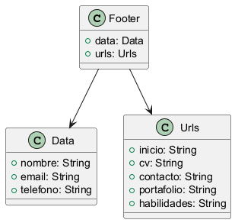

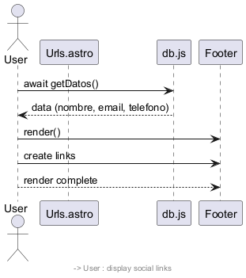

# Time Complexity Analysis

The provided code snippet is part of a component that utilizes asynchronous data fetching and rendering through an Astro framework. Here's a breakdown of the time complexity:

1. Data Retrieval (`await getDatos();`):

- The function `getDatos()` is called to fetch data asynchronously. The time complexity of this operation depends on the implementation of `getDatos()`, which is not provided. Assuming it involves a typical database query, the time complexity can range from O(1) (if data is cached) to O(n) (where n is the number of records fetched from the database). The actual complexity will depend on factors such as database indexing and the nature of the query.

2. Conditional Rendering (`data?.nombre`, `data?.email`, `data?.telefono`):

- The use of optional chaining (e.g., `data?.nombre`) is O(1) for each property access, as it merely checks for the existence of the property.

3. Static Rendering of HTML Elements:

- Rendering the HTML structure within the footer is O(1) as the number of elements (e.g., paragraphs, links) is constant and does not depend on input size or other dynamic factors.

4. Dynamic Links (`urls`):

- The code accesses various properties of the `urls` object (e.g., `urls.inicio`, `urls.cv`, etc.). Similar to property access for `data`, this is O(1) for each access.

5. SVG Rendering:

- The SVG elements are also rendered statically, contributing O(1) for the rendering of each SVG. The complexity remains constant regardless of external factors.

6. CSS Styling:

- The CSS styling does not contribute to the time complexity of the rendering process but can affect rendering performance depending on the complexity of styles applied. However, CSS itself is not typically analyzed in time complexity.

### Overall Complexity

When combining the above analyses, the overall time complexity for the component rendering can be summarized as:

- Best Case: O(1) if `getDatos()` retrieves the data quickly and the content remains constant.

- Worst Case: O(n) if `getDatos()` involves a time-consuming database operation to fetch data.

In practice, the rendering of the footer itself is O(1) since the structure is static, while the data fetching introduces variability based on the size and complexity of the data source. Therefore, the final time complexity of the entire snippet primarily hinges on the complexity of the `getDatos()` function.

## Code Review Summary

### Identified Issues

1. Error Handling for Async Calls: The function `getDatos()` is called using `await` but there is no error handling in case the promise is rejected. This could lead to unhandled promise rejections.

2. Potential Null Reference: The use of optional chaining (`data?.nombre`, `data?.email`, etc.) is a good practice, but it would be better to ensure that `data` is defined before attempting to access its properties. This can prevent rendering issues if `data` is null or undefined.

3. SVG Accessibility: The SVG elements used for icons are missing `aria-labels` or titles that describe their purpose, which could impact accessibility for screen readers.

4. Target Attribute Typo: The `target="_blanc"` should be corrected to `target="_blank"`.

5. Hardcoded URLs: The LinkedIn and GitHub URLs are hardcoded. It would be better to store these in a configuration file or constants to avoid potential issues with changes in the URLs.

### Recommendations for Improvement

1. Error Handling: Implement try-catch blocks around the `getDatos()` call to handle any potential errors gracefully.

```javascript

let data;

try {

data = await getDatos();

} catch (error) {

console.error('Error fetching data:', error);

}

```

2. Ensure Data Validity: Before using `data`, check if it is defined and handle the case where it might not be.

3. Accessibility Enhancements: Add titles or `aria-labels` to the SVG elements for better accessibility.

4. Refactor Target Attribute: Update the `target` attributes from `_blanc` to `_blank`.

5. Configuration for URLs: Store the URLs in a separate configuration file or as constants to make future updates easier.

### Areas of Strength

- Use of Modern JavaScript Features: The code uses modern features like async/await and optional chaining effectively, which enhances readability and maintainability.

- Semantic HTML: The use of semantic HTML elements (like footer, divs, etc.) improves the accessibility and structure of the page.

- Responsive Design: The CSS includes media queries to ensure that the footer is responsive, which is great for usability on different screen sizes.

### Potential Bugs

- If `getDatos()` fails, the `data` variable may remain undefined, leading to potential crashes when trying to render properties of `data`.

- Missing accessibility features in SVG can lead to important information being inaccessible to users relying on assistive technologies.

### Performance Bottlenecks

- The current implementation is straightforward and does not seem to introduce any significant performance issues. However, the SVG icons should be optimized (if they are large) to reduce load times, especially if the page contains many icons.

### Security Vulnerabilities

- Ensure the data fetched from `getDatos()` is sanitized before rendering, especially if it includes user-generated content (like email addresses or names). This can prevent XSS (Cross-Site Scripting) attacks.

### Overall Code Quality Assessment

Score: 7/10

- The code demonstrates good structure and modern practices but requires improvements in error handling, accessibility, and minor corrections for a higher quality rating.

Version 1.0

Provide a technical overview of the class, its purpose, and its features.

### Explanation -

Code Summary for Documentation:

This code is a component that renders a user’s skills in a web application using Astro, a modern static site generator. It begins by importing necessary components such as `Footer`, `Header`, and `SkillCard`, along with a general layout component `Layout` that structures the page. Additionally, it imports a type definition `Habilidad` for TypeScript support and functions for fetching user data and skills from a database.

The main content is encapsulated within the `Layout` component, where the title dynamically reflects the user's name fetched from the database. Inside the main section, the `Header` component is displayed, followed by a heading that introduces the skills section.

A key feature of this component is the rendering of skill cards. The `habilidades` array, obtained through asynchronous fetching, is mapped to create individual `SkillCard` components. Each card is wrapped in a link (`

Version 1.0

Provide a technical overview of the class, its purpose, and its features.

### Explanation -

Code Summary for Documentation:

This code snippet defines a header component for a web application using Astro framework, which imports URL paths from a separate configuration file. The header includes a logo section and a navigation menu.

### Structure

1. Header Section:

- Contains a `div` for displaying a logo, which is an SVG graphic linked to the homepage.

- The logo consists of two SVG icons, providing visual branding for the application.

2. Navigation Menu:

- A `nav` element includes an unordered list (`ul`) of navigation links.

- Each list item (`li`) contains anchor tags (`a`) that lead to various sections of the site, such as "Inicio", "Currículum Vitae", "Contacto", "Portafolio", and "Habilidades". The URLs for these links are dynamically sourced from the imported `urls`.

### Styling

- The header is styled with a light gray background, centered text, and rounded corners, providing a modern look.

- Navigation links appear inline with margins for spacing and change color on hover to enhance user interaction.

- The logo section (`.dr`) features a scaling effect on hover to draw attention.

- Media queries ensure responsiveness; on screens smaller than 600px, navigation links stack vertically, providing a better user experience on mobile devices.

### Functionality

The code structure promotes modularity and reusability by separating URLs into a dedicated file. It enhances user experience with interactive elements and ensures accessibility across different device sizes. The use of CSS transitions adds a polished feel to user interactions. Overall, the header is designed to be intuitive, visually appealing, and responsive.

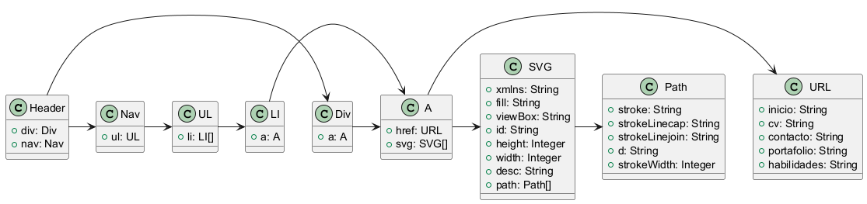

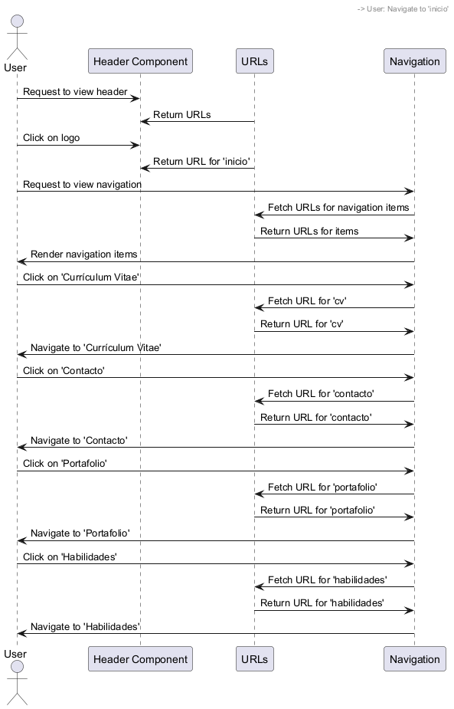

## Time Complexity Analysis

The provided code snippet primarily consists of HTML and CSS with some JavaScript functionality (importing URLs). This code is structured to create a header and navigation bar for a web page.

### Analysis of Components

1. HTML Structure:

- The HTML portion includes a header with navigation links. The number of links is fixed (5 links) and does not depend on any input size.

- Each link has a constant time complexity for rendering, which is O(1) for each link. The total complexity for creating the list of links is O(n), where n is the number of links. In this case, n = 5, hence it is O(5) or simply O(1) since constants are disregarded in Big O notation.

2. SVG Icons:

- The SVG elements used for the icons are also static and do not have any computational complexity associated with them. They are rendered directly and have O(1) complexity.

3. CSS Styles:

- The CSS is responsible for styling the header and navigation elements. The rendering of styles is generally considered to have O(1) complexity as it does not depend on input size or the number of elements being styled. The performance impact is negligible.

4. Responsive Design:

- The media queries used for responsive design do not add to the time complexity of rendering the elements but rather adjust the styles based on the screen size. This is a constant-time operation as it is still based on the predefined styles.

### Conclusion

The overall time complexity of the code snippet can be summarized as follows:

- The rendering of the header and navigation links is O(1) since it always involves a fixed number of elements.

- The inclusion of SVGs and CSS does not contribute to further complexity.

Thus, the final time complexity of the entire code snippet is O(1). This indicates that the performance of the header and navigation rendering remains constant and efficient, regardless of any external factors such as user input or data size.

Code Review Summary

### Identified Issues

1. SVG Accessibility: The SVG icons do not have `aria-label` attributes or `

Version 1.0

Provide a technical overview of the class, its purpose, and its features.

### Explanation -

Code Summary for Documentation:

This code represents an Astro component that serves as the main page layout for a personal website. It imports necessary components such as `Header`, `Footer`, `Layout`, and `Card`, as well as a function `getDatos` for fetching user data from a database. The `data` object is retrieved asynchronously and used to dynamically populate the page content.

The layout begins with a title that incorporates the user's name from the fetched data. The main section includes a welcoming header and a brief introduction about the user, highlighting their passions and encouraging visitors to explore the site. This section is designed to provide a personal touch, making it inviting for users.

The page also includes a navigation section featuring three cards that link to different parts of the site: the user's CV, portfolio, and skills. Each card is represented by the `Card` component, which receives props for the theme, image, and URL, visually enhancing the navigation experience.

Styling for the page is defined within a `

Version 1.0

Provide a technical overview of the class, its purpose, and its features.

### Explanation -

Code Summary for Documentation:

The provided code defines a TypeScript interface named `Habilidad`, which is intended to represent a skill or ability within an application. Interfaces in TypeScript allow for the definition of a structure that objects can conform to, ensuring consistency and type safety.

The `Habilidad` interface contains the following properties:

1. id (number): This property serves as a unique identifier for each skill. It allows for efficient referencing and retrieval of skill data within collections or databases.

2. img (string): This property holds the URL of an image associated with the skill. This could be used for displaying icons or graphics that represent the skill visually in the user interface.

3. nombre (string): This property represents the name of the skill. It is a textual description that users will see, making it essential for user interaction and understanding.

4. descripcion (string): This property provides a brief description of the skill. It is intended to give users more context or details about what the skill entails, enhancing the overall user experience.

5. url (string): This property contains a URL linking to additional resources or information related to the skill. This could be a link to documentation, tutorials, or other relevant web pages that provide further insights.

Overall, the `Habilidad` interface is designed to encapsulate all necessary details about a skill, making it easier for developers to manage, display, and interact with skill-related data in their applications. By adhering to this interface, developers can ensure that all skill objects maintain a consistent structure across the codebase, facilitating better maintainability and readability.

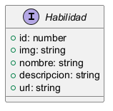

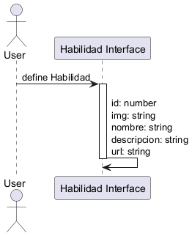

Time Complexity Analysis

The provided code snippet defines an interface `Habilidad` in TypeScript, which acts as a blueprint for creating objects that represent a skill. Since an interface is primarily a structural definition and does not contain any executable logic or data manipulation, there is no inherent time complexity associated with it.

### Key Points:

- Interface Definition: The `Habilidad` interface defines the structure and types of properties (id, img, nombre, descripcion, url) that each skill object should have.

- No Executable Code: As the code does not include any functions or algorithms, there are no loops or operations that would contribute to time complexity.

- Usage Context: The actual time complexity will depend on how this interface is implemented in the application. For instance, if you create an array of `Habilidad` objects and perform operations like searching or sorting, then the time complexity of those operations would need to be analyzed separately.

In conclusion, the interface itself does not have a time complexity, but its implementation in actual code would determine any associated complexities.

Code Review Summary

### Identified Issues

- No significant issues were found in the code snippet provided. The interface is well-structured and serves its purpose effectively.

### Recommendations for Improvement

- Documentation: While comments are present, consider using JSDoc style comments for better integration with documentation tools. This will enhance readability and provide automatic documentation generation capabilities.

- Validation: Consider adding validation or constraints for the properties, especially for `url` and `img`, to ensure they contain valid URLs. This can be done at the implementation stage rather than in the interface.

### Areas of Strength

- Clarity: The interface is clear and self-explanatory. Each property is well-defined, making it easy for other developers to understand the purpose of the interface.

- Type Safety: Utilizing TypeScript's type system effectively enhances code reliability and maintainability.

### Potential Bugs

- No potential bugs are identified in the current snippet. However, ensure that the consuming code properly handles invalid or unexpected data types when implementing this interface.

### Performance Bottlenecks

- There are no performance bottlenecks in this code snippet. The interface is lightweight and does not introduce any overhead.

### Security Vulnerabilities

- No immediate security vulnerabilities are evident in the interface itself. However, when dealing with URLs, ensure that they are sanitized and validated in the implementation to prevent potential security risks like XSS (Cross-Site Scripting).

### Overall Code Quality Assessment

Score: 8/10

The code is well-structured and adheres to good practices. Improvement can be made in documentation and validation. With minor adjustments, it could achieve a higher quality score.

Version 1.0

Provide a technical overview of the class, its purpose, and its features.

### Explanation -

Code Summary for Documentation:

This code snippet defines a basic HTML structure using the Astro framework, demonstrating how to set up a web page template with dynamic properties and global styles.

1. Props Interface: An interface named `Props` is defined to specify the expected properties for the component. In this case, it requires a single property called `title`, which is of type `string`. This structure promotes type safety and clarity in the component's API.

2. Destructuring Props: The `title` property is extracted from `Astro.props`, allowing the use of the title value within the HTML document.

3. HTML Document Setup: The core of the code consists of a standard HTML document structure:

- The document type is declared as HTML5 (`

html

`).

- The `

Version 1.0

Provide a technical overview of the class, its purpose, and its features.

### Explanation -

Code Summary for Documentation:

This code snippet is a component for an Astro framework application used to render a portfolio page. It imports essential components such as `Footer`, `Header`, and `ProjectCard`, and a layout wrapper named `Layout`. It also imports two asynchronous functions, `getDatos` and `getProjects`, from a database module to fetch user data and project information.

Upon execution, the component first awaits the results from `getDatos()` and `getProjects()`, storing the fetched user data and projects in the variables `data` and `projects`, respectively. The `Layout` component is then rendered, with the page title dynamically set based on the user's name fetched from `data`.

Inside the `Layout`, a `main` section is defined, which includes the `Header` component and a heading for the projects. A `div` is used to contain the project cards, where the `projects` array is mapped over. Each project is wrapped in an anchor tag that links to a specific project page, with the `ProjectCard` component being instantiated for each project.

Styling is incorporated directly within the component using a `

Version 1.0

Provide a technical overview of the class, its purpose, and its features.

### Explanation -

Code Summary for Documentation:

The provided code snippet is a React component implemented in Astro, which renders a project card with various details about a software project. The component extracts a `project` object from Astro's properties, which contains essential information such as the project URL, image, name, description, and a list of technologies used.

The main structure is encapsulated in an anchor (`

` tag and a description in a `` tag.- Another nested `` for displaying technology icons, which includes a heading "Technologies" and maps over the `project.tecnologias` array. Each technology is represented as an image within an anchor tag linking to the respective technology's URL, allowing users to click through to more information.Styling is applied via a `

` tag.

- Another nested `

Version 1.0

Provide a technical overview of the class, its purpose, and its features.

### Explanation -

Code Summary for Documentation:

This code snippet is a component designed to display a skill card using Astro, a framework for building fast websites. The component begins by extracting a `skill` object from the component's properties, which contains details about a specific skill, including an image, name, and description.

The card is structured using HTML, with an image element that displays the skill's image and uses the skill's name as an alt text for accessibility. Below the image, there is a heading (`

`) that presents the skill's name and a paragraph (``) that emphasizes the skill's level using bold text.Styling for the card is applied using CSS. The `.card` class encapsulates the overall appearance of the card, including margin, padding, border, border-radius, and a subtle box-shadow to create a three-dimensional effect. A smooth transformation effect is implemented for hover interactions, which slightly raises the card and enhances the shadow, providing visual feedback to users.The image is styled to take the full width of the card while maintaining a fixed height, ensuring a consistent layout. The headings and paragraphs within the card are styled for readability, with defined colors and font sizes.Additionally, media queries are employed to adjust the card's width and margin for smaller screens, ensuring a responsive design.Overall, this component effectively presents skill-related information in a visually appealing manner, prioritizing usability and responsiveness. The design principles used enhance the user experience, making it suitable for applications that require skill showcasing, such as portfolios or dashboards.

`) that emphasizes the skill's level using bold text.

Styling for the card is applied using CSS. The `.card` class encapsulates the overall appearance of the card, including margin, padding, border, border-radius, and a subtle box-shadow to create a three-dimensional effect. A smooth transformation effect is implemented for hover interactions, which slightly raises the card and enhances the shadow, providing visual feedback to users.

The image is styled to take the full width of the card while maintaining a fixed height, ensuring a consistent layout. The headings and paragraphs within the card are styled for readability, with defined colors and font sizes.

Additionally, media queries are employed to adjust the card's width and margin for smaller screens, ensuring a responsive design.

Overall, this component effectively presents skill-related information in a visually appealing manner, prioritizing usability and responsiveness. The design principles used enhance the user experience, making it suitable for applications that require skill showcasing, such as portfolios or dashboards.

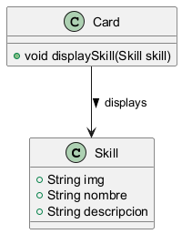

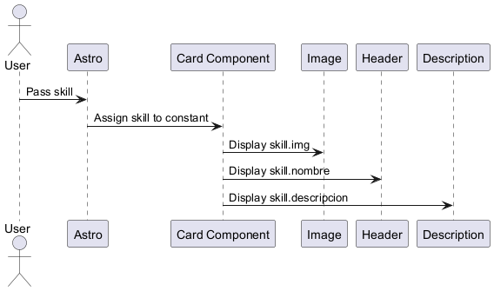

Time Complexity Analysis

The provided code snippet consists of a simple HTML structure with embedded JavaScript, CSS styling, and the use of the Astro framework. Here's a breakdown of the time complexity considerations:

1. JavaScript Execution:

- The line where `const skill = Astro.props.skill;` is executed has a time complexity of O(1), as it simply assigns a property from an object to a constant variable.

2. Rendering the HTML:

- The HTML rendering itself does not involve loops or recursive functions. The elements are statically defined and will be rendered directly based on the assigned properties. Thus, the time complexity for rendering the HTML elements is also O(1).

3. CSS Styling:

- The CSS defined in the `

Version 1.0

Provide a technical overview of the class, its purpose, and its features.

### Explanation -

Code Summary for Documentation:

The provided code snippet defines a JavaScript object named `urls` that serves as a centralized repository for routing paths within a web application. This object is exported for use in other modules, allowing consistent access to the defined routes throughout the application.

Each property of the `urls` object corresponds to a specific section of the application and maps to a relative URL path. The following properties are defined:

- `inicio`: This property is set to `"/#"`, which represents the root path of the application, often used as the landing page or home section.

- `cv`: The property `cv` is assigned the value `"cv"`, indicating the path for the curriculum vitae section of the application.

- `contacto`: The `contacto` property is defined with the value `"contacto"`, which corresponds to the contact section where users can reach out for inquiries.

- `portafolio`: The `portafolio` property maps to the path `"portafolio"`, intended for displaying the user's portfolio content.

- `habilidades`: Lastly, the `habilidades` property is set to `"habilidades"`, leading to the skills section of the application.

This structured approach to defining routes enhances code maintainability and readability. By centralizing URL definitions, developers can easily manage and update paths without needing to search through multiple files. Furthermore, utilizing an object for URLs minimizes the chances of typographical errors and fosters consistency in route usage across the application. This design pattern is especially beneficial in larger applications where multiple components may need to reference the same paths. Overall, the `urls` object serves as a crucial element in routing management within the application.

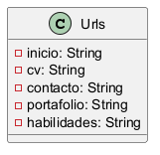

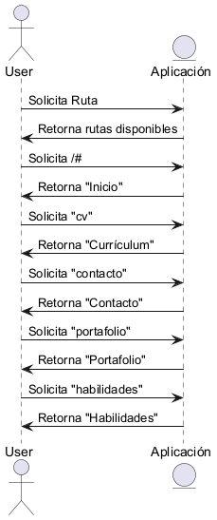

Time Complexity Analysis

The provided code snippet defines a JavaScript object named `urls` that contains key-value pairs for different application routes. Since the code only consists of a static object definition without any loops or recursive calls, the time complexity analysis is straightforward.

1. Initialization: The object is initialized with predefined string values. This operation takes constant time, denoted as O(1), because it does not depend on the size of any input.

2. Accessing Properties: Accessing properties of the object (e.g., `urls.inicio`, `urls.cv`, etc.) also operates in constant time, O(1), since JavaScript objects provide average-case constant time complexity for property access.

In summary, the overall time complexity for both the initialization of the object and accessing its properties is O(1). There are no significant performance concerns or dependencies on input size in this code snippet.

Code Review Summary

### Identified Issues

1. Consistency in URL Paths: The URL for the home page uses a hash (`/#`), while the other paths do not include a leading slash. This inconsistency could lead to confusion and potential routing issues.

### Recommendations for Improvement

1. Standardize URL Formats: Ensure all URLs either use a leading slash or do not use one uniformly. For example:

```javascript

export const urls = {

inicio: "/",

cv: "/cv",

contacto: "/contacto",

portafolio: "/portafolio",

habilidades: "/habilidades",

};

```

2. Comment Clarity: The comments are helpful, but consider making them more descriptive. For instance, specify that the paths are relative to the base URL.

### Areas of Strength

- Clarity: The use of descriptive keys for each path improves readability and maintainability.

- Simplicity: The structure is straightforward, making it easy for future developers to understand the purpose of each route.

### Potential Bugs

- If the application expects URLs to start with a leading slash, the inconsistency could lead to routing errors when navigating between sections.

### Performance Bottlenecks

- There are no significant performance concerns with this snippet as it primarily defines static paths.

### Security Vulnerabilities

- No immediate security vulnerabilities are apparent. However, ensure that these routes are validated and sanitized if they are used in a context that involves user input or redirects.

### Overall Code Quality Assessment

Score: 7/10

- The code is generally well-structured and clear, but minor improvements in consistency and documentation could enhance its quality.